Year 11 Foundation Mathematics

Probability Test

2021


Name: ______________________ Time: 30 minutes Total Mark:____/23
(5%)

Question 1 5 marks

Use words to describe the chances of the following events occurring:

  - Tomorrow will be Saturday __________________________

  - You will win the lottery __________________________

  - Tails will land on a coin flip __________________________

  - You will be in Year 12 next year __________________________

  - Next year will have 365 days __________________________

Question 2 5 marks

A bag contains twelve marbles; 4 blue, 3 red and the rest yellow.

- Which colour marble are you most likely to grab out of the bag?

- Order the colours of marbles from least likely to most likely from being picked from the bag.

- If all the yellow marbles are removed from the bag, which colour are you most likely to grab?

Question 3 4 marks

certain
impossible

Mark and label the following on the above probability scale:

a) Rolling a 6 on a six-sided dice

b) Heads will land on a coin flip

c) A triangle will have 3 sides

d) Rolling a 7 on six-sided dice

Question 4 4 marks

Circle the event that is more likely to occur:

a) Winning the Australian lottery OR Winning the local community raffle

b) Twins being born OR Triplets being born

c) Drawing the Queen of Clubs from a deck OR Drawing a red card from a deck

d) Rolling a 2 on six-sided dice OR Flipping a heads on a coin

Question 4 1 mark

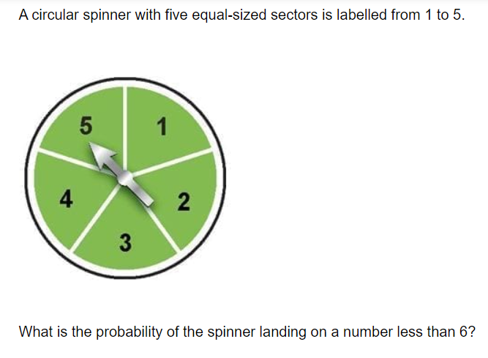
Circle the correct answer

a) 0 b) $\frac{5}{6}$ c) 1 d) 5

Question 5 1 mark

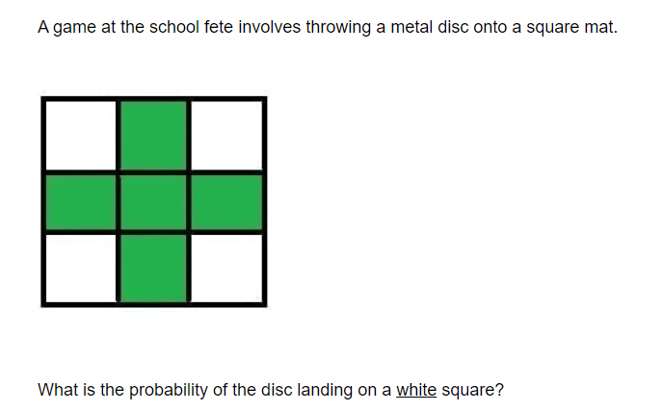

Question 6 3 marks

The following graph shows the amount of rainfall in Hawaii over four days.

a) There is a surfing competition on the weekend in Hawaii. Use words to describe the chances of it raining on the weekend.

b) The competition will be cancelled if there is over 20mm of rain. Based on the past four days of rainfall, is it likely the competition will be cancelled? Use the language of chance in your answer.

c) A severe rain warning occurs when more than 80mm of rain is predicted. Based on the past four days of rainfall, is it likely a severe rain warning could occur? Use the language of chance in your answer.

END OF TEST

